**Build a Night Security Light with Arduino**

In this project you’re going to build a night security light with a relay module, a photoresistor and an Arduino.



A night security light only turns on when it’s dark and when movement is detected.

Here’s the main features of this project:

* the lamp turns on when it’s dark AND movement is detected;
* when movement is detected the lamp stays on for 10 seconds;
* when the lamp is ON and detects movement, it starts counting 10 seconds again;
* when there’s light, the lamp is turned off, even when motion is detected.

**Recommended resources**

The following resources include guides on how to use the relay module and the PIR motion sensor with the Arduino, which might be useful for this project.

* [Guide for Relay Module with Arduino](https://randomnerdtutorials.com/guide-for-relay-module-with-arduino/)
* [Arduino with PIR Motion Sensor](https://randomnerdtutorials.com/arduino-with-pir-motion-sensor/)

**Parts required**

Here’s a complete list of the parts required for this project:

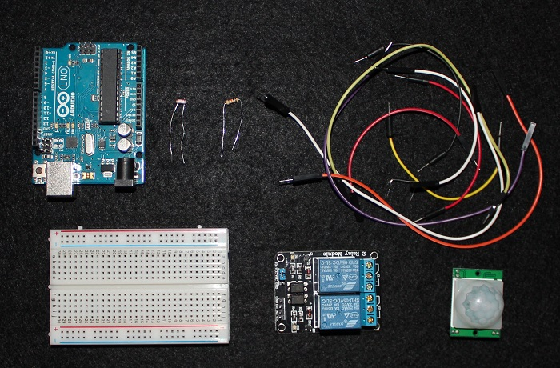

* [Arduino UNO](https://makeradvisor.com/tools/compatible-arduino-uno-r3-board/) – read [Best Arduino Starter Kits](https://makeradvisor.com/best-arduino-starter-kits/)
* [PIR Motion Sensor](https://makeradvisor.com/tools/pir-motion-sensor-hc-sr501/)
* [Photoresistor](https://makeradvisor.com/tools/photoresistor-light-dependent-resistor-ldr/)
* [10kOhm resistor](https://makeradvisor.com/tools/resistors-kits/)
* [Relay module](https://makeradvisor.com/tools/5v-2-channel-relay-module-optocoupler/)
* Lamp cord set ([view on eBay)](http://ebay.to/2feHELc)
* [Breadboard](https://makeradvisor.com/tools/mb-102-solderless-breadboard-830-points/)
* [Jumper wires](https://makeradvisor.com/tools/jumper-wires-kit-120-pieces/)

Besides these electronics components, you also need an AC male socket, an AC wire and a lamp bulb holder (a lamp cord set). My lamp cord set is the one in the figure below.

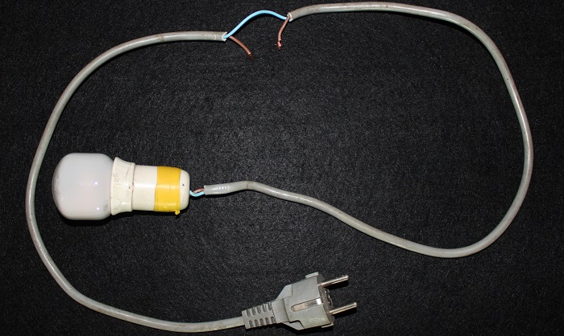

You can use the preceding links or go directly to [MakerAdvisor.com/tools](https://makeradvisor.com/tools/?utm_source=rnt&utm_medium=post&utm_campaign=post) to find all the parts for your projects at the best price!

[](https://makeradvisor.com/tools/?utm_source=rnt&utm_medium=post&utm_campaign=post)

**Code**

Download or copy the following code to your Arduino IDE, and upload it to your Arduino board.

**Warning: do not upload a new code to your Arduino board while your lamp is connected to the mains voltage. You should unplug the lamp from mains voltage, before upload a new sketch to your Arduino.**

/*

* Rui Santos

* Complete Project Details https://randomnerdtutorials.com

*/

// Relay pin is controlled with D8. The active wire is connected to Normally Closed and common

int relay = 8;

volatile byte relayState = LOW;

// PIR Motion Sensor is connected to D2.

int PIRInterrupt = 2;

// LDR pin is connected to Analog 0

int LDRPin = A0;

// LDR value is stored on LDR reading

int LDRReading;

// LDR Threshold value

int LDRThreshold = 300;

// Timer Variables

long lastDebounceTime = 0;

long debounceDelay = 10000;

void setup() {

// Pin for relay module set as output

pinMode(relay, OUTPUT);

digitalWrite(relay, HIGH);

// PIR motion sensor set as an input

pinMode(PIRInterrupt, INPUT);

// Triggers detectMotion function on rising mode to turn the relay on, if the condition is met

attachInterrupt(digitalPinToInterrupt(PIRInterrupt), detectMotion, RISING);

// Serial communication for debugging purposes

Serial.begin(9600);

}

void loop() {

// If 10 seconds have passed, the relay is turned off

if((millis() - lastDebounceTime) > debounceDelay && relayState == HIGH){

digitalWrite(relay, HIGH);

relayState = LOW;

Serial.println("OFF");

}

delay(50);

}

void detectMotion() {

Serial.println("Motion");

LDRReading = analogRead(LDRPin);

// LDR Reading value is printed on serial monitor, useful to get your LDRThreshold

//Serial.println(LDRReading);

// Only turns the Relay on if the LDR reading is higher than the LDRThreshold

if(LDRReading > LDRThreshold){

if(relayState == LOW){

digitalWrite(relay, LOW);

}

relayState = HIGH;

Serial.println("ON");

lastDebounceTime = millis();

}

}

[View raw code](https://github.com/RuiSantosdotme/Random-Nerd-Tutorials/raw/master/Projects/Night_Security_Light_with_Arduino.ino)

**Schematics**



Here’s the schematics for this project.

[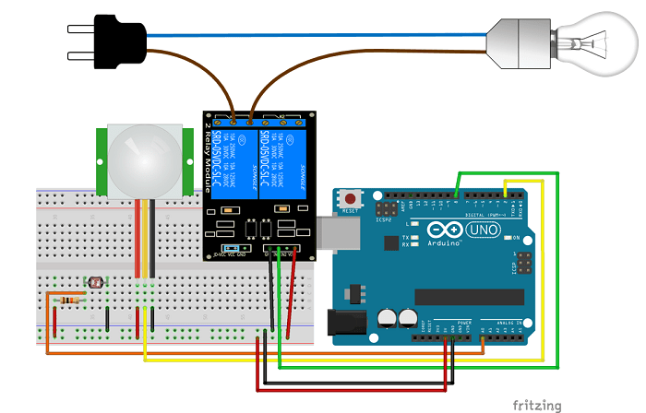](https://i0.wp.com/randomnerdtutorials.com/wp-content/uploads/2017/06/Schematics_f.png?quality=100&strip=all&ssl=1)

**Note**: if you have an earth (GND) connection in the mains voltage cable – a yellow and green cable – it should go outside the relay module, like the blue wire (neutral).

**Demonstration**

Here’s your circuit in action:



**Wrapping up**

In this project you’ve built a night security light with a photoresistor and a PIR motion sensor.

This is a great project to practice with relays and with the PIR motion sensor.

If you like Arduino projects, make sure you check our latest Arduino course: [**Arduino Step-by-step Projects – Build 25 Projects**](https://randomnerdtutorials.com/arduino-step-by-step-projects/)

Thanks for reading,

Sara Santos